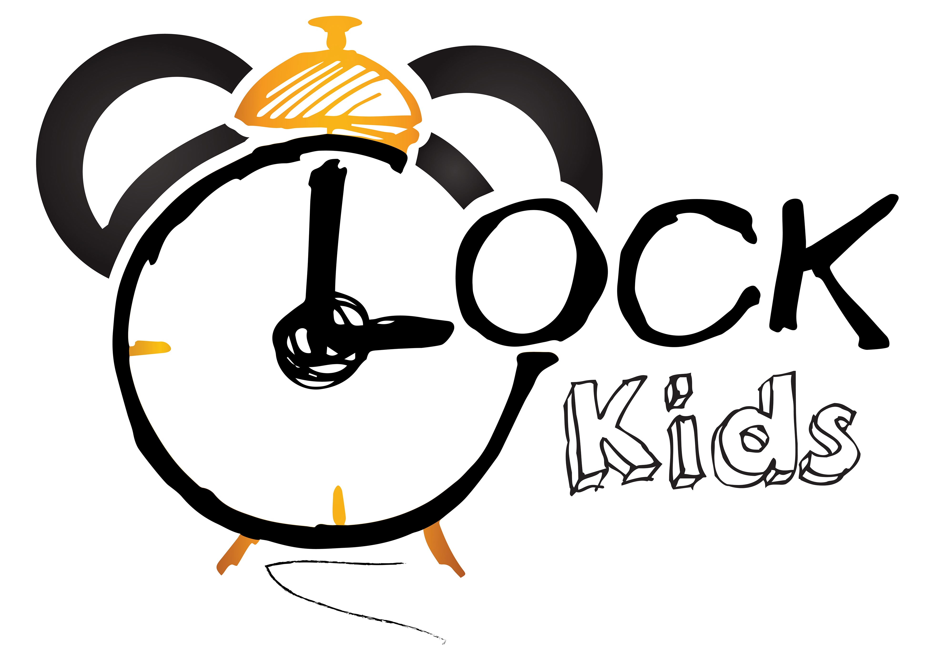Słowa i zwroty, które pojawią się na spotkaniach w LISTOPADZIE:

Powitanie – rymowanka  Hello! (Hello!)  Hello! (Hello!)  Come in.  Let's sing.  Let's play.  Hello! (Hello!)  Hello! (Hello!)  Knock, knock, knock.  Come on in!  Let's sing.  And play.  And learn together.  Knock, knock!  Zwroty i wyrażenia:  Hello – witaj  Come (on) in – wejdź  Let’s sing – zaśpiewajmy  Let’s play – pobawmy się  Knock – puk, puk  Learn together – uczmy się razem  Dingle dangle scarecrow - piosenka  When all the cows/sheep were sleeping  and the sun had gone to bed,  Up jumped the scarecrow  and this is what he said:  “I’m a dingle dangle scarecrow  with a flippy floppy hat,  I can shake my hands like this  and shake my feet like that.”  Zwroty i wyrażenia:  When all the cows/sheep were sleeping – kiedy wszystkie krówki/owieczki spały  and the sun had gone to bed – i Słońce poszło spać  Up jumped the scarecrow – nagle wyskoczył strach na wróble  and this is what he said - i to właśnie powiedział  I’m a dingle dangle scarecrow – jestem bujającym się strachem na wróble  with a flippy floppy hat – z opadającym kapeluszem  I can shake my hands like this – mogę trząść rękoma tak właśnie  and shake my feet like that – mogę trząść stopami tak właśnie  Old McDonald had a farm! – piosenka:  What does a COW say? Moo.  Old McDonald had a farm. E-I-E-I-O.  And on that farm he had a COW. E-I-E-I-O. What does a HORSE say?  Neigh, neigh.  Old McDonald had a farm. E-I-E-I-O.  And on that farm he had a HORSE  What does a PIG say?  Oink, oink.  Old McDonald had a farm. E-I-E-I-O. And on that farm he had a PIG. E-I-E-I-O.  Old McDonald had a farm. E-I-E-I-O.  What does a SHEEP say?  Baaa, baaa.  Old McDonald had a farm. E-I-E-I-O.  And on that farm he had a SHEEP. E-I-E-I-O. What does a DUCK say?  Quack, quack.  Old McDonald had a farm. E-I-E-I-O.  And on that farm he had a DUCK. E-I-E-I-O. Old McDonald had a farm. E-I-E-I-O.  What does a ROOSTER say?  Cock-a-doodle-doo!  Old McDonald had a farm. E-I-E-I-O.  And on that farm he had a ROOSTER. E-I-E-I-O.  Zwroty i wyrażenia:  What does a COW/HORSE/PIG/SHEEP/DUCK/ROOSTER say? – jaki dźwięk wydaje krowa/koń/świnka/owca/kaczka/kogut?  Old McDonald had a farm – stary McDonald miał farmę  And on that farm he had a COW/HORSE/PIG/SHEEP/DUCK/ROOSTER – i na tej farmie miał krowę/konia/świnkę/owcę/kaczkę/koguta  Row your boat – piosenka:  Row, row, row your boat,  Gently down the stream.  Merrily, merrily, merrily, merrily,  Life is but a dream.  Zwroty i wyrażenia:  Row, row, row your boat- wiosłuj, wiosłuj, wiosłuj łódź  Gently down the stream – delikatnie ze strumieniem  Merrily - radośnie  Life – życie  Dream – sen | Small Talk/Flashcards (clothes)  Is it a hat/a jumper/a skirt/a jacket/a boot?  Yes, it is/ No, it isn’t  Is it a hat/a jumper/a skirt/a jacket/a boot? – czy to jest kapelusz/sweter/spódnica/kurtka/but  Yes, it is/ No, it isn’t – tak, jest/nie, nie jest  Zwroty i wyrażenia programu przedszkolnego:  POLAND: flag, white, red – Polska: flaga, biały, czerwony  MY TOWN – moje miasteczko  MY FAMILY: mummy, daddy, brother, sister, baby, grandma, grandpa – mamusia, tatuś, brat, siostra, dziecko, babcia, dziadek  MY HOME: living room, bedroom, bathroom, kitchen, stairs – salon, sypialnia, łazienka, kuchnia, schody  AUTUMN WEATHER: windy, rainy, cloudy – wietrznie, deszczowo, pochmurnie  Jesienne kolory- Autumn colours  Red, yellow, brown, orange- czerwony, zółty, brązowy, pomarańczowy  MY HEALTH / HYGIENE – moje zdrowie / higiena  I can wash my face, hands – Potrafię myć swoją twarz, dłonie  TEDDY BEAR DAY – Dzień Pluszowego Misia  PETS – zwierzęta domowe  Dog- pies  Cat- kot  Hamster- chomik  Tematy: warzywa, owoce, zmysły oraz uczucia zrealizowane w październiku  Good Bye! Song  Bye, Good Bye,  I can clap my hands/I can stamp my feet  Bye, Bye, Good Bye!  Zwroty i wyrażenia:  Good Bye! – Do widzenia!  I can clap my hands/I can stamp my feet – potrafię klaskać rękoma/potrafię tupać stopami

