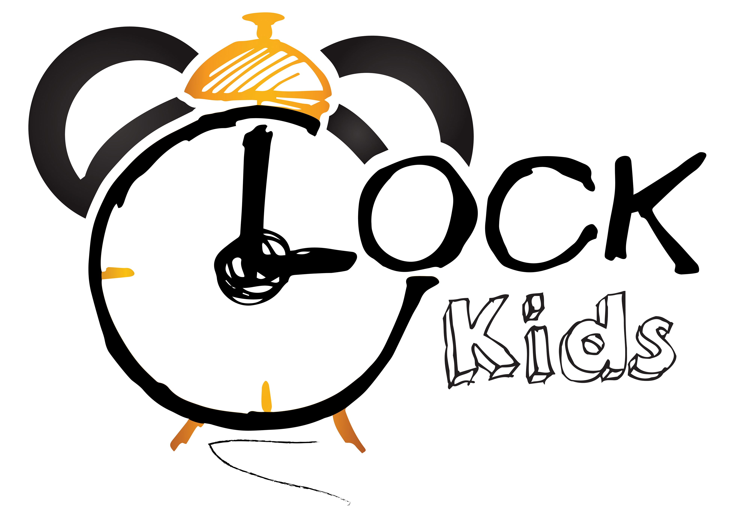Słowa i zwroty, które pojawią się na spotkaniach w MAJU:

Powitanie – rymowanka  Hello, hello.  Can you clap your hands?  Hello, hello.  Can you clap your hands?  Can you stretch up high?  Can you touch your toes?  Can you turn around?  Can you say, "Hello"?  Hello, hello.  Can you stamp your feet?  Hello, hello.  Can you stamp your feet?  Can you stretch up high?  Can you touch your toes?  Can you turn around?  Can you say, "Hello"?  Hello, hello.  Can you clap your hands?  Hello, hello.  Can you stamp your feet?  Zwroty i wyrażenia:  Can you clap your hands – czy możesz zaklaskać rękoma  Can you stretch up high – czy możesz rozciągnąć się w górę  Can you touch your toes – czy możesz dotknąć palce u stóp  Can you turn around – czy możesz się obrócić  Can you say, "Hello"? - czy możesz powiedzieć „cześć”?  Can you stamp your feet – czy możesz tupać stopami  I love my mummy, I love my daddy – piosenka  I love my mummy,  Yes, I do!  Here is a kiss and a hug for you!  Thank you mummy for all you do!  Happy Mother’s Day! I love you!  I love my daddy,  Yes, I do!  Here is a kiss and a hug for you!  Thank you daddy for all you do!  Happy Father’s Day! I love you!  Zwroty i wyrażenia:  I love my mummy – kocham moją mamusię  Here is a kiss and a hug for you! – oto buziak i przytulenie dla ciebie  Thank you mummy for all you do! – dziękuję ci mamusiu za wszystko co robisz  Happy Mother’s Day! I love you! – szczęśliwego Dnia Mamy, kocham Cię!  I love my daddy- kocham mojego tatusia  Happy Father’s Day! I love you! – szczęśliwego Dnia Taty, kocham Cię!  We are going to the sea - rymowanka  We are going to the sea,  Mum, dad, Mark and me,  By car, by plane, by train, by bus,  Why don’t you come with us?  By car it is nice, hurray!  Hopping, what an exciting day!  We are going to the sea,  Mum, dad, Mark and me,  By car, by plane, by train, by bus,  Why don’t you come with us?  By plane it is fast, hurray! 1  Let’s go at last! What an exciting day!  We are going to the sea,  Mum, dad, Mark and me,  By car, by plane, by train, by bus,  Why don’t you come with us?  By train it is cool, hurray!  Waiting to star! What an exciting day!  We are going to the sea,  Mum, dad, Mark and me,  By car, by plane, by train, by bus,  Why don’t you come with us?  By bus it is great! Hurray!  Let’s go, don’t be late! What an exciting day!  We are going to the sea,  Mum, dad, Mark and me,  By car, by plane, by train, by bus,  Why don’t you come with us?  Zwroty i wyrażenia:  We are going to the sea – my jedziemy nad morze  Mum, dad, Mark and me – mama, tata, Mark i ja  By car, by plane, by train, by bus – samochodem, samolotem, pociągiem, autobusem  Why don’t you come with us? – może pojedziesz z nami?  By car it is nice, hurray! – samochodem jest fajnie! Hura!  Hopping, what an exciting day! – podskakiwanie, cóż za ekscytujący dzień  By plane it is fast, hurray! – samolotem  jest szybko, hura!  Let’s go at last! What an exciting day! – chodźmy w końcu! Cóż za ekscytujący dzień!  By train it is cool, hurray! – pociągiem jest super, hura!  Waiting to start! What an exciting day! – czekanie aż ruszy! Co za ekscytujący dzień!  By bus it is great! Hurray! – autobusem jest wspaniale, hura!  Let’s go, don’t be late! What an exciting day! – chodź, nie spóźniaj się! Cóż za ekscytujący dzień!  Alphabet song – piosenka:  A, B, C, D, E, F, G  H, I, J, K, L, M, N, O, P  Q, R, S, T, U, V  W, X, Y, Z  Now I know my ABCs.  Next time won't you sing with me?  A, B, C, D, E, F, G  H, I, J, K, L, M, N, O, P  Q, R, S, T, U, V  W, X, Y, and Z  Now I know my ABCs.  Next time won't you sing with me?  Zwroty i wyrażenia:  Now I know my ABCs – teraz znam moje ABC  Next time won't you sing with me? – następnym razem może zaśpiewasz ze mną?  2 | A sailor went to sea- piosenka  A sailor went to sea sea sea  to see what she could see see see.  But all that she could see see see  was the bottom of the deep blue sea sea sea.  A seahorse!  A sailor went to sea sea sea  to see what she could see see see.  But all that she could see see see  was a seahorse swimming in the sea sea sea.  A jellyfish!/A turtle!/An octopus!/ A baby shark!/A blue whale!  Zwroty i wyrażenia:  A sailor went to sea- żeglarka wyruszyła w morze  to see what she could see- żeby przekonać się co może zobaczyć  But all that she could see- ale jedyne co widziała  was the bottom of the deep blue sea- to dno głębokiego, niebieskiego morza  A seahorse!- konik morski!  A seahorse swimming in the sea- konik morski pływający w morzu  A jellyfish!/A turtle!/An octopus!/ A baby shark!/A blue whale!- meduza/ ośmiornica/ mały rekin/ płetwal błękitny  Zwroty i wyrażenia:  Good Bye! – Do widzenia!  I can clap my hands/I can stamp my feet – potrafię klaskać rękoma/potrafię tupać stopami Zwroty i wyrażenia programu przedszkolnego:  Town:  Library- biblioteka  cinema – kino  gas stadion – stacja paliw  school – szkoła  hospital – szpital  bank – bank  post office – poczta  church – kościół  restaurant – restauracja  Special Days in May:  Flag – flaga  Country – kraj  Parents’ Day:  Mummy – mamusia  Daddy- tatuś  Mother’s Day- Dzień mamy  Father’s Day- Dzień ojca  Thomas’ alphabet – piosenka:  A is for Annie, B is for Bertie, C is for Clarabel, D is for Diesel, E is for engine sched, F is for Fat Controller, G is for Gordon, H is for Harold, I is for ice cream, J is for James, K is for kite, L is for luggage, M is for mountains, N is for news paper, O is for ostrich, P is for Percy, Q is for queue, R is for railway Line, S is for signal, T is for Thomas, U is for umbrella, V is for van, W is for window, X is for Xmas, Y is for yacht, Z is for zebra  Zwroty i wyrażenia:  is for – jest dla  engine shed - maszynownia  Fat Controller – gruby kontroler  Ice carem - lody  Kite - latawiec  Luggage - bagaż  Mountains - góry  Newspaper - gazeta  Ostrich - struś  Queue - kolejka  railway line – tory kolejowe  signal - sygnał  umbrella - parasol  van - wan  window - okno  Xmas – Święta Bożego Narodzenia  Yacht - jacht  Zebra - zebra

