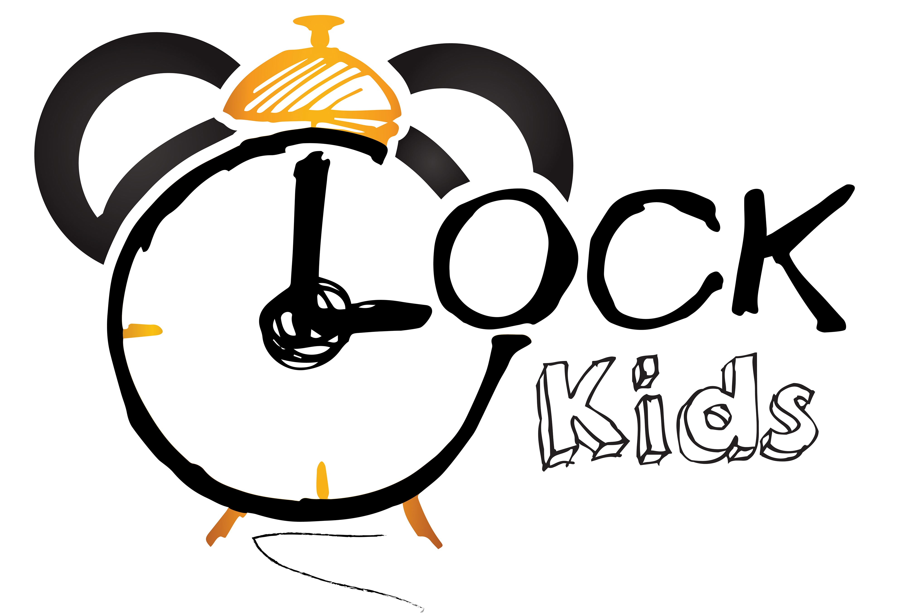Słowa i zwroty, które pojawią się na spotkaniach w KWIETNIU:

Powitanie – rymowanka  Hello! (Hello!)  Hello! (Hello!)  Come in.  Let's sing.  Let's play.  Hello! (Hello!)  Hello! (Hello!)  Knock, knock, knock.  Come on in!  Let's sing.  And play.  And learn together.  Knock, knock!  Zwroty i wyrażenia:  Hello – witaj  Come (on) in – wejdź  Let’s sing – zaśpiewajmy  Let’s play – pobawmy się  Knock – puk, puk  Learn together – uczmy się razem  The Shape Song 2 - piosenka  A triangle. Can you make a triangle  A triangle. Can you find a triangle? Ready...GO!  A rectangle. Can you make a rectangle?  A rectangle. Can you find a rectangle Ready...GO!  An oval. Can you make an oval  An oval. Can you find an oval  Ready...GO!  A star. Can you make a star  A star. Can you find a star?  Ready...GO!  A triangle, a rectangle, an oval, and a star.....  Zwroty i wyrażenia:  Can you make/find a triangle? – czy potrafisz zrobić/znaleźć trójkąt  Can you make/find a rectangle? – czy potrafisz zrobić/znaleźć prostokąt  Can you make/find a oval? – czy potrafisz zrobić/znaleźć owal  Can you make/find a star? – czy potrafisz zrobić/znaleźć gwiazdę  Ready...GO! – gotowy… ruszaj!  The way the bunny hops - piosenka  This is the way the bunny hops, hop hop hop, hop  hop, hop, hop  This is the way the bunny hops on Easter day  This is the way he wiggles his nose, wiggle. wiggle, wiggle, wiggle  wiggle, wiggle, wiggle  This is the way the bunny wiggles his nose on Easter day  This is the way he flops his ears, flop, flop, flop. flop  flop, flop, flop  This is the way he flops his ears on Easter day  This is the way he shakes his tail, shake, shake, shake, shake  shake, shake, shake  This is the way he shakes his tail on Easter day  This is the way the bunny hops, hop hop, hop, hops  hop, hop, hop  This is the way the bunny hops on Easter day  On Easter day  Zwroty i wyrażenia:  This is the way the bunny hops on Easter day – w ten sposób króliczek skacze w wielkanocny dzień 1  he wiggles his nose – on kręci swoim  noskiem  he flops his ears – on opuszcza swoje uszka, he shakes his tail – on macha swoim ogonkiem  The Hokey Pokey Shake – piosenka:  You put one hand in.  You put one hand out.  And you shake, shake, shake, shake, shake.  You do the Hokey Pokey and turn around.  Everybody, turn around.  You put two hands in.  You put two hands out.  And you shake, shake, shake, shake, shake.  You do the Hokey Pokey and clap your hands.  Everybody, clap your hands.  You put one foot in.  You put one foot out.  You put one foot in.  And you shake, shake, shake, shake, shake.  You do the Hokey Pokey and sit down.  Everybody please sit down.  You put two feet in.  You put two feet out.  You put two feet in.  And you shake, shake, shake, shake, shake.  You do the Hokey Pokey and stand up.  Everybody, please stand up.  You put your head in.  You put your head out.  You put your head in.  And you shake, shake, shake, shake, shake.  You do the Hokey Pokey and sing a song.  La, la, la, la, la, la!  You put your backside in.  You put your backside out.  You put your backside in.  And you shake, shake, shake, shake, shake.  You do the Hokey Pokey and be quiet.  Everybody, please be quiet. Shh!  You put your whole self in.  Your whole self out.  Your whole self in.  And you shake, shake, shake, shake, shake.  You do the Hokey Pokey and take a bow.  Everybody, take a bow.  Zwroty i wyrażenia:  You put one hand/foot/head/backside/whole self in – ustaw swoją głowę/stopę/głowę/tył/całego siebie do środka  You put one hands/feet out - ustaw swoje ręce.stopy na zewnątrz  And you shake – a teraz potrząśnij  You do the Hokey Pokey and turn around – ty robisz Hokey Pokey i kręcisz się  Everybody, turn around – każdy, niech się kręci  Everybody, clap your hands – każdy, niech klapie w dłonie  Everybody, please stand up – każdy, niech wstanie proszę  You do the Hokey Pokey and sing a song – ty robisz Hokey Pokey i śpiewasz piosenkę  Everybody, please be quiet – każdy, niech będzie cicho proszę  Everybody, take a bow – każdy, niech się ukłoni  2 | Small Talk/ Animals (flashcards)  Toucan – tukan  Camel – wielbłąd  Zebra – zebra  Koala – koala  Aligator – aligator  Buffalo – bawół  Rhino – nosorożec  Grilla – goryl  Hippo – hipopotam  Kangaroo – kangur  Fish – ryba  Panda – panda  Giraffe – żyrafa  Whale – wieloryb  Shark – rekin  Hen – kura  Chicken – kurczak  Rooster – kogut  Goose – geś  B-U-N-N-Y rhyme  There is a rabbit with a pink nose – jest króliczek z różowym nosem  Floppy ears and a fluffy tail – opadającymi uszami i puszystym ogonkiem  And Bunny is his name-O – i króliczek to jego imie  B-U-N-N-Y  Good Bye! Song  Bye, Good Bye,  I can clap my hands/I can stamp my feet  Bye, Bye, Good Bye!  Zwroty i wyrażenia:  Good Bye! – Do widzenia!  I can clap my hands/I can stamp my feet – potrafię klaskać rękoma/potrafię tupać stopami  3 Zwroty i wyrażenia programu przedszkolnego:  EASTER:  Easter – Wielkanoc  Easter egg – pisanka  Basket – koszyk  Lamb – baranek  Bunny – króliczek  FARM:  Sheep –owca  Cow – krowa  Dog – pies  Cat – kot  Horse – koń  Pig – świnia  Chicken - kurczak  Farmer - rolnik  POLAND:  Poland – Polska  Flag – flaga  Red- czerwony  White – biały  PLANET  Planet- planeta  Earth- ziemia  Recycling- recykling  4

