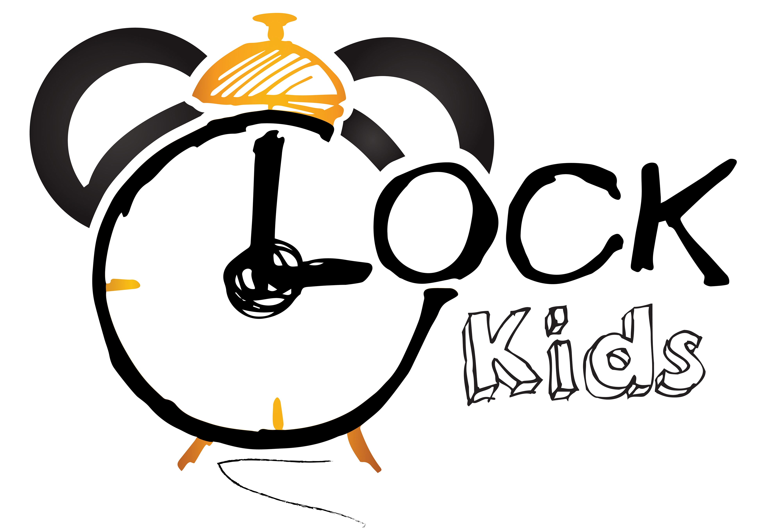Słowa i zwroty, które pojawią się na spotkaniach w LISTOPADZIE:

Powitanie – rymowanka  Hello! (Hello!)  Hello! (Hello!)  Come in.  Let's sing.  Let's play.  Hello! (Hello!)  Hello! (Hello!)  Knock, knock, knock.  Come on in!  Let's sing.  And play.  And learn together.  Knock, knock!  Zwroty i wyrażenia:  Hello – witaj  Come (on) in – wejdź  Let’s sing – zaśpiewajmy  Let’s play – pobawmy się  Knock – puk, puk  Learn together – uczmy się razem  Old McDonald had a farm! – piosenka:  What does a COW say? Moo.  Old McDonald had a farm. E-I-E-I-O.  And on that farm he had a COW. E-I-E-I-O. What does a HORSE say?  Neigh, neigh.  Old McDonald had a farm. E-I-E-I-O.  And on that farm he had a HORSE  What does a PIG say?  Oink, oink.  Old McDonald had a farm. E-I-E-I-O. And on that farm he had a PIG. E-I-E-I-O.  Old McDonald had a farm. E-I-E-I-O.  What does a SHEEP say?  Baaa, baaa.  Old McDonald had a farm. E-I-E-I-O.  And on that farm he had a SHEEP. E-I-E-I-O. What does a DUCK say?  Quack, quack.  Old McDonald had a farm. E-I-E-I-O.  And on that farm he had a DUCK. E-I-E-I-O. Old McDonald had a farm. E-I-E-I-O.  What does a ROOSTER say?  Cock-a-doodle-doo!  Old McDonald had a farm. E-I-E-I-O.  And on that farm he had a ROOSTER. E-I-E-I-O.  Zwroty i wyrażenia:  What does a COW/HORSE/PIG/SHEEP/DUCK/ROOSTER say? – jaki dźwięk wydaje krowa/koń/świnka/owca/kaczka/kogut?  Old McDonald had a farm – stary McDonald miał farmę  And on that farm he had a COW/HORSE/PIG/SHEEP/DUCK/ROOSTER – i na tej farmie miał krowę/konia/świnkę/owcę/kaczkę/koguta | Small Talk/Flashcards (clothes)  Is it a hat/a jumper/a skirt/a jacket/a boot?  Yes, it is/ No, it isn’t  Is it a hat/a jumper/a skirt/a jacket/a boot? – czy to jest kapelusz/sweter/spódnica/kurtka/but  Yes, it is/ No, it isn’t – tak, jest/nie, nie jest  Zwroty i wyrażenia programu przedszkolnego:  POLAND: flag, white, red – Polska: flaga, biały, czerwony  MY FAMILY: mummy, daddy, brother, sister, baby – mamusia, tatuś, brat, siostra, dziecko  AUTUMN WEATHER: windy, rainy, cloudy – wietrznie, deszczowo, pochmurnie  AUTUMN COLOURS - Jesienne kolory- Autumn colours  Red, yellow, brown, orange- czerwony, zółty, brązowy, pomarańczowy  MY HEALTH: I can wash my face, hands – Potrafię myć swoją twarz, dłonie  TEDDY BEAR DAY – Dzień Pluszowego Misia  CLOTHES: shoes (buty), jacket (kurtka), scarf (szalik), hat (czapka), umbrella (parasol)  PLEASE / NO, THANK YOU – proszę / nie, dziękuję  Good Bye! Song  Bye, Good Bye,  I can clap my hands/I can stamp my feet  Bye, Bye, Good Bye!  Zwroty i wyrażenia:  Good Bye! – Do widzenia!  I can clap my hands/I can stamp my feet – potrafię klaskać rękoma/potrafię tupać stopami

