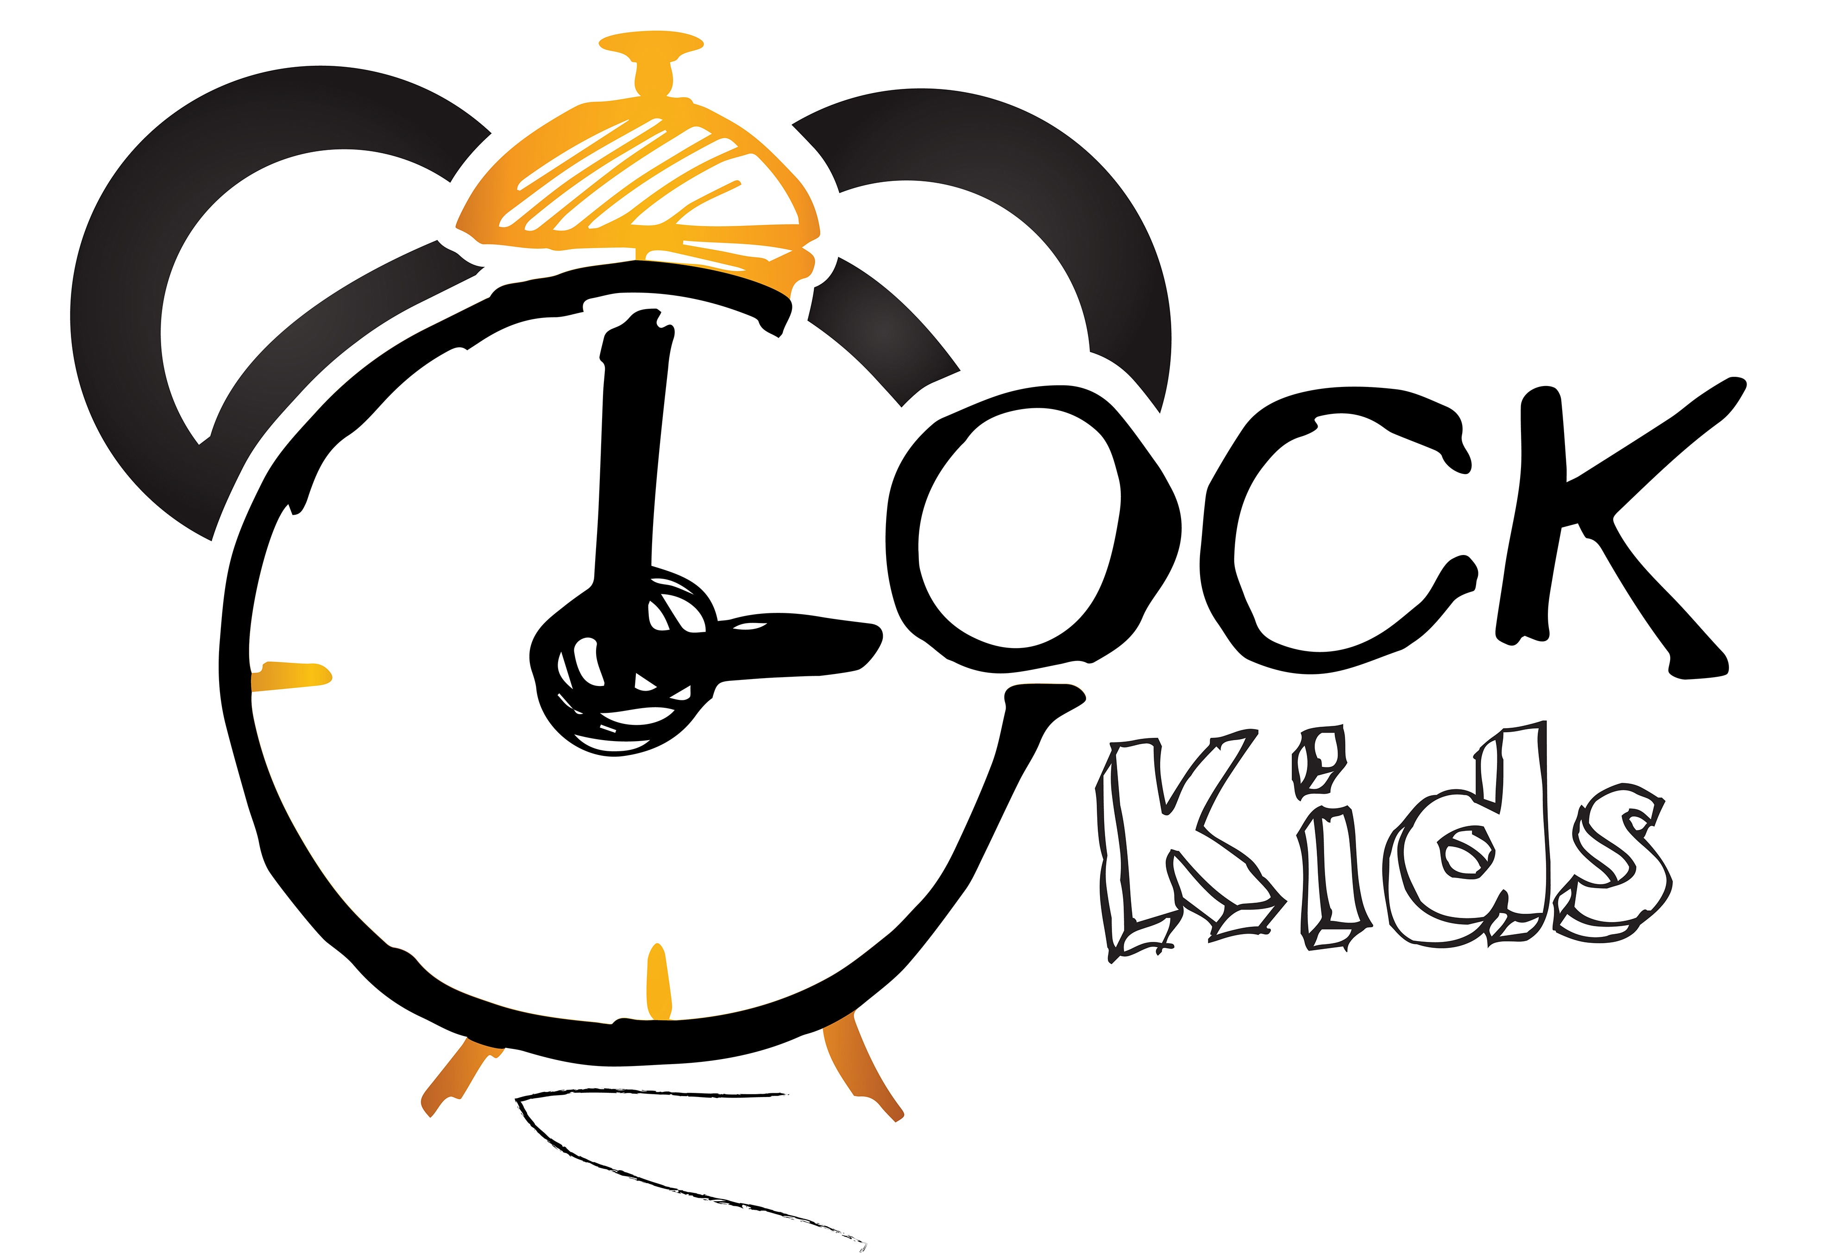Słowa i zwroty, które pojawią się na spotkaniach w GRUDNIU:

Powitanie – piosenka  Hello, reindeer.  Hello, snowman.  Hello, Santa.  Happy holidays.  Happy holidays.  Merry Christmas, everyone  Let's sing it once again.  Zwroty i wyrażenia:  Hello, Reindeer – witaj reniferze  Hello, showman – witaj bałwanku  Hello, Santa – witaj Święty Mikołaju  Happy holidays – wesołych świąt  Merry Christmas, everyone – wesołych świąt wszystkim  Let's sing it once again – zaśpiewajmy jeszcze raz  I’m A Little Snowman - piosenka  I'm a little snowman, look at me.  These are my buttons, 1 2 3.  These are my eyes and this is my nose.  I wear a hat and scarf. Brrr...it's cold!  Zwroty i wyrażenia:  I'm a little snowman, look at me – jestem małym bałwankiem, spójrz na mnie  These are my buttons – to są moje guziki  These are my eyes and this is my nose – to są moje oczy i to jest mój nos  I wear a hat and scarf – ja noszę czapkę i szalik It's cold – jest zimno  SANTA – piosenka:  Red hat, white beard, twinkle in his eye.  Santa is his name-o.  S-A-N-T-A  S-A-N-T-A  S-A-N-T-A  And Santa is his name-o  Zwroty i wyrażenia:  Red hat, white beard, twinkle in his eye – czerwona czapka, biała broda, błysk w jego oku  Santa is his name – Mikołaj to jego imię  Snowflake – piosenka:  Snowflake, snowflake, little snowflake.  Little snowflake falling from the sky.  Snowflake, snowflake, little snowflake.  Falling, falling, falling, falling, falling,  falling, falling, falling, falling...  falling in my hand.  Falling on my head.  Falling on my nose.  Falling in my hand.  Zwroty i wyrażenia:  Little snowflake falling from the sky – mała śnieżynka spada z nieba  Falling in my hand – spada na moją rękę  Falling on my head – spada na moją głowę  Falling on my nose – spada na mój nos  Falling in my hand – spada na moją dłoń  Santa on his way – piosenka:  What do you want for Christmas? Christmas? Christmas?  What do you want for Christmas?  Santa's on his way.  I want a ball.  I want a ball.  I want a ball to bounce.  Bounce? Bounce!  What do you want for Christmas? Christmas? Christmas?  What do you want for Christmas? Santa's on his way.  I want a yo-yo.  I want a yo-yo.  I want a yo-yo to spin.  Spin? Spin!  Christmas? Christmas?  What do you want for Christmas? Santa's on his way.  I want a bike.  I want a bike.  I want a bike to ride.  Ride? Ride!  What do you want for Christmas? Christmas? Christmas?  What do you want for Christmas? Santa's on his way.  I want a jump rope.  I want a jump rope.  I want a jump rope to jump.  Jump? Jump!  What do you want for Christmas? Christmas? Christmas?  What do you want for Christmas? Santa's on his way.  Santa's on his way!  Zwroty i wyrażenia:  What do you want for Christmas? –co chcesz dostać na Święta?  Santa's on his way – Święty Mikołaj jest w drodze  I want a ball/ yo-yo/ bike/ jump rope – ja chcę piłkę/ jo-jo/ rower/ skakankę  Ten Little elves – piosenka:  1 little, 2 little, 3 little elves,  4 little, 5 little, 6 little elves,  7 little, 8 little, 9 little elves,  10 little elves are making toys.  1 little, 2 little, 3 little elves,  4 little, 5 little, 6 little elves,  7 little, 8 little, 9 little elves,  10 little elves are sewing.  1 little, 2 little, 3 little elves,  4 little, 5 little, 6 little elves,  7 little, 8 little, 9 little elves,  10 little elves are painting.  1 little, 2 little, 3 little elves,  4 little, 5 little, 6 little elves,  7 little, 8 little, 9 little elves,  10 little elves are sawing.  1 little, 2 little, 3 little elves,  4 little, 5 little, 6 little elves,  7 little, 8 little, 9 little elves,  10 little elves are hammering.  1 little, 2 little, 3 little elves,  4 little, 5 little, 6 little elves,  7 little, 8 little, 9 little elves,  10 little elves are wrapping.  1 little, 2 little, 3 little elves,  4 little, 5 little, 6 little elves,  7 little, 8 little, 9 little elves,  10 little elves are sleeping.  Zwroty i wyrażenia:  Little elves –małe elfy  Sewing – szyć  Painting – malować  Sawing – piłować  Making toys – robić zabawki  Hammering – uderzać młotkiem  Wrapping – pakować  Sleeping – spać | Christmas tree – piosenka  I’m a dancing Christmas tree  Everybody is dancing with me  Shake your hand  Kick your legs  Wave your arms  Zwroty i wyrażenia:  I’m a dancing Christmas tree – jestem tańczącą choinką  Everybody is dancing with me – wszyscy tańczą ze mną  Shake your hand – potrząsaj dłońmi  Kick your legs – kop nogami  Wave your arms – machaj rękoma  Small Talk/Flashcards (clothes- powtórzenie)  Is it a hat/a jumper/a skirt/a jacket/a boot? – jaka jest pogoda?  Yes, it is/ No, it isn’t  Is it a hat/a jumper/a skirt/a jacket/a boot? – jaka jest pogoda? – czy to jest kapelusz/sweter/spódnica/kurtka/but  Yes, it is/ No, it isn’t – tak, jest/nie, nie jest  Powtórzenie (weather):  Rainy/snowy/stormy/hail/hot/cold – deszczowo/ śnieżnie/ burzowo/ grad/ gorąco/ zimno  Good Bye! Song  Goodbye, snowman.  Goodbye, reindeer.  Goodbye, Santa.  Happy holidays.  Happy holidays!  We wish you a Merry Christmas.  Zwroty i wyrażenia:  Goodbye, snowman – żegnaj bałwanku  Goodbye, Reindeer – żegnaj reniferze  Goodbye, Santa – żegnaj Święty Mikołaju  Happy holidays – wesołych świąt  We wish you a Merry Christmas – życzymy Wam Wesołych Świąt  Zwroty i wyrażenia programu przedszkolnego:  CHRISTMAS TIME: Chritmas tree, Chritmas decorations, presents, balls, lights, star – choinka, świąteczne dekoracje, prezenty, bombki, światełka, gwiazda  SANTA: Red hat, white beard, twinkle in his eye – czerwona czapka, biała broda, błysk w jego oku  Santa is his name – Mikołaj to jego imię  WINTER AND WITNER ANMALS: snowflake, snowball, snow, snowman, polar bear, penguin, bird – śnieżynka, kulka ze śniegu, śnieg, bałwan, niedźwiedź polarny, pingwin, ptak  MINER’S DAY: miner – Dzień Górnika, górnik

