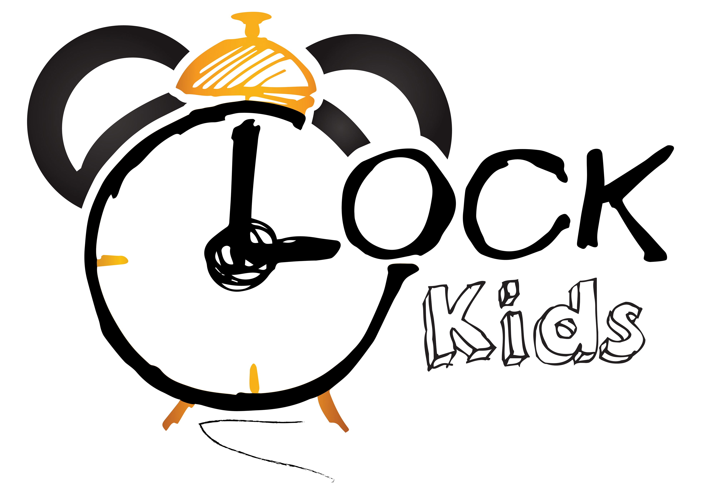Słowa i zwroty, które pojawią się na spotkaniach w MARCU:

Powitanie – rymowanka  Hello!  How are you?  I’m good/great/wonderful!  I’m tired/hungry/not so good!  How are you? – jak się masz?  I’m good/great/wonderful- mam się dobrze/bardzo dobrze/wspaniale  I’m tired/hungry/not so good – jestem zmęczony/głodny/nie za dobrze się czuję  Five little ducks - piosenka  Five little ducks  Went out one day  Over the hill and far away  Mother duck said  "Quack, quack, quack, quack."  But only four little ducks came back.  Four little ducks  Went out one day  Over the hill and far away  Mother duck said  "Quack, quack, quack, quack."  But only three little ducks came back.  Three little ducks  Went out one day  Over the hill and far away  Mother duck said  "Quack, quack, quack, quack."  But only two little ducks came back.  Two little ducks  Went out one day  Over the hill and far away  Mother duck said  "Quack, quack, quack, quack."  But only one little duck came back.  One little duck  Went out one day  Over the hill and far away  Mother duck said  "Quack, quack, quack, quack."  But none of the five little ducks came back.  Sad mother duck  Went out one day  Over the hill and far away  The sad mother duck said  "Quack, quack, quack."  And all of the five little ducks came back.  Zwroty i wyrażenia:  Five little ducks – pięć małych kaczątek  Went out one day – wyszło pewnego dnia  Over the hill and far away – za górę, daleko  Mother duck said – mama kaczka powiedziała  "Quack, quack, quack, quack." – kwa kwa  But only four little ducks came back – ale tylko cztery wróciły 1  One/two/three/four/five- jeden/dwa/trzy/cztery/pięć  The sad mother duck said – smutna mama kaczka powiedziała  And all of the five little ducks came back – i wszystkie pięć małych kaczątek wróciło  Spring song! – piosenka  S-P-R-I-N-G!  Zwroty i wyrażenia:  Spring - wiosna  Spring is here! – piosenka:  I can see the rainbow  I can hear the birds  I can feel the Sun  Spring is here!  I can see the butterflies  I can hear the bees  I can feel the wind  Goodbye Winter  Hello Spring  A new start for everything  Goodbye snow  Hello Sun  Let’s go outside and have some fun  I can see the cherry trees  I can hear the frogs  I can smell the flowers  I have a runny nose  I have itchy eyes  I have a fever  Zwroty i wyrażenia:  I can see the rainbow – widzę tęczę  I can hear the birds – słyszę ptaki  I can feel the Sun – czuję Słońce  Spring is here! – Wiosna tutaj jest!  I can see the butterflies – widzę motyle  I can hear the bees – słyszę pszczoły  I can feel the wind – czuję wiatr  Goodbye Winter – żegnaj Zimo  Hello Spring – witaj Wiosno  A new start for everything – nowy początek dla wszystkiego  Goodbye snow – żegnaj śniegu  Hello Sun – witaj Słońce  Let’s go outside and have some fun – chodźmy na dwór i pobawmy się  I can see the cherry trees – widzę wiśnie  I can hear the frogs – słyszę żaby  I can smell the flowers – wącham kwity  I have a runny nose – mam katar  I have itchy eyes – mam bolące oczy  I have a fever – mam gorączkę  The Shape Song - piosenka  A circle. A circle. Can you make a circle?  Can you find a circle? Ready...GO!  I know...let's make a diamond. Can you make a diamond? Here we go...  A diamond. A diamond. Can you make a diamond?  Can you find a diamond? Ready...GO!  Hmm...what's next? How about a square?  A square. A square. Can you make a square?  Can you find a square? Ready...GO!  Alright. Time for one more. Let's try a heart.  A heart. A heart. Can you make a heart? 2 | Small Talk/School vocabulary  Jobs (zawody):  Cook – kucharz  Teacher – nauczyciel  Seller – sprzedawca  Nurse – pielęgniarka  Postman – listonosz  Farmer – rolnik  Fireman – strażak  Doctor, dentist, hospital – lekarz, dentist, szpital  Policeman – policjant  Vet – weterynarz  Shoemaker- szewc  See you later, Alligator! Song  Goodbye, goodbye.  It's time to go.  I don't want to go  See you later.  Alligator.  Butterfly.  Goodbye!  Zwroty i wyrażenia:  Goodbye – do widzenia  It's time to go – już czas iść  I don't want to go – ja nie chcę iść  See you later – do zobaczenia później  Alligator - aligatorze  Butterfly - motyl  Zwroty i wyrażenia programu przedszkolnego:  SPRING: WIOSNA  Frog is jumping – żaba skacze  Bee is flying – pszczoła lata  Mosquito is biting – komar gryzie  Blue bird is singing – niebieski ptak śpiewa  Ladybird is flying – biedronka lata  Spring colours: green, yellow, orange, pink – wiosenne kolory: zielony, żółty, pomarańczowy, różowy  SPRING FLOWERS: WIOSENNE KWIATY  Daisy – stokrotka  Snowdrops – przebiśniegi  Tulip – tulipan  Daffodil – żonkil  Crocus – krokus  Violet – fiołek  Lilac – bez  Iris – irys  Freesia – frezja  EASTER: WIELKANOC  Easter, bunny, eggs, basket- Wielkanoc, króliczek, jajka, koszyk 4  Can you find a heart? Ready...GO!  A circle, a diamond, a square, and a heart.  Zwroty i wyrażenia:  Can you make/find a circle? – czy potrafisz zrobić/znaleźć koło  Can you make/find a diamond? – czy potrafisz zrobić/znaleźć diament  Can you make/find a square? – czy potrafisz zrobić/znaleźć kwadrat  Can you make/find a heart? – czy potrafisz zrobić/znaleźć serce  Music Man - piosenka  I am the music man. I come from far away and I can play. (What can you play?)  I play the piano. Pia pia piano piano piano – Pia pia piano pia piano  I am the music man. I come from far away and I can play. (What can you play?)  I play the violin. Vio vio violin violin violin – Vio vio violin vio violin  Pia pia piano piano piano – Pia pia piano pia piano  I am the music man. I come from far away and I can play. (What can you play?)  I play the saxophone. Saxo saxo saxophone saxophone saxophone  Saxo saxo saxophone saxo saxophone  Vio vio violin violin violin – Vio vio violin vio violin  Pia pia piano piano piano – Pia pia piano pia piano  I am the music man. I come from far away and I can play. (What can you play?)  I play the big bass drum. Big bass big bass big bass drum big bass drum big bass drum  Big bass big bass big bass drum big bass big bass drum  Saxo saxo saxophone saxophone saxophone – Saxo saxo saxophone saxo saxophone  Vio vio violin violin violin – Vio vio violin vio violin  Pia pia piano piano piano – Pia pia piano pia piano  I am the music man. I come from far away and I can play. (What can you play?)  Well, I can play everything and here we go! Hit it! Play that piano. Play that violin.  Play that saxophone. Play that big bass drum.  Zwroty i wyrażenia:  I am the music man – jestem muzykiem  I come from far away and I can play – pochodzę z daleka i umiem grać  Piano - pianino  Violin - skrzypce  Saxophone - saksofon  Big bass drum – duży bęben  3

